
CYB 150-T01 Cybersecurity Foundations
MODULE 9: CHAPTER 11: EXERCISE 11.4

November 7, 2025
Professor: Karry Elson
Student: Jamison Durham

Table of Contents
Chapter 11: Exercise 11.4 Learning About Audits………………………………………………………………………………….2
Chapter 11: Case Study………………………………………………………………………………………………………………………...4
References……………………………………………………………………………………………………………………………………………6

Chapter 11: Exercise 11.4 Learning about audits

Assignment:
Using the resources given or other resources, find at least one sample security audit plan.

Analyze that document.

Write a brief essay giving your opinion of that plan. Do you feel the audit plan is adequate? What changes might you recommend?

Assignment response:
Analysis:
Security Audits are one of the most fundamental requirements for any cybersecurity department for a business. Security audits being the regular and repeated evaluation of an organization security to eliminate and lower vulnerabilities, test controls, and to maintain regulations and policies. One of the more popular standards for security audits being the NIST 800-115 or NSA-IAM. More specifically SANS institute has numerous policy templates such as the Software Development Management Policy. These plans are meant to better the company to limit vulnerabilities. For example, an audit report by Fort Worth city in Texas, was released on December 18, 2020, to review concerns and vulnerabilities.
The objective of the report was to assess the overall security of the effective security policies and security controls that were in place. This report used the scope to state the City’s information technology policies and mechanisms that were currently in place during the fiscal year 2020.
The methodology states that the report used the NIST 800-115 structure and outline for their audit plan and report. The cybersecurity team of Fort Worth were also able to interview staff from the IT (Information Technology) Solutions department. Through this, they were able to review multiple key points such as, computer assets used by the city, the IT’s risk assessment process, public websites, network vulnerabilities scans. In the audit results of the report, the auditor states, “We reviewed CFW network account password requirements, and found them to be adequate and appropriate for ensuring that access to CFW network and related software systems is effectively controlled” (Randle 4). This is just one example of how the audit was formatted and how they revealed the results of the audit. Further results suggest that multi-factor authentication for remote VPN access would soon be part of the policy, along with the continuation of operations and already established plans.

Personal Overview:
Overall, this audit plan released by Fort Worth in 2020 was professionally written with a clear and organized structure. Referring to the common audit templates, the Fort Worth audit clearly followed the NIST framework. The report was well structured with a clear objective followed by a clear plan and then ending in results for the audit. Given that the report was done by a city, I was pleased to read that the report of the local government was able to overview their many assets. This shows how they were able to evaluate their controls and policies, maintaining consistency as there was another report done in May of 2021. The audit clearly lists the problems and their efforts to resolve the issues, as well as highlighting areas where the audit was successful.
One of the main critiques that raise concern was how the report failed to establish what was changed or manipulated to resolve the issue. Although they included some minor details, majority of the report focused on the before and after of review such as their addition to multifactor identification. Understanding that this was a public audit report of a government system might bring a better understanding of why some of the information was limited or bare. Although moving forward, I would include a log of specific additions or subtractions to each reviewed subject. One thing that I would have liked to see in the report was a mention of disaster recovery for the city’s IT assets.
Although overall, I was able to clearly understand the audit report and findings. Clearly using NIST, this report brought a better understanding of the importance of audit plans, as a company or government system should review their concerns and systems regularly.

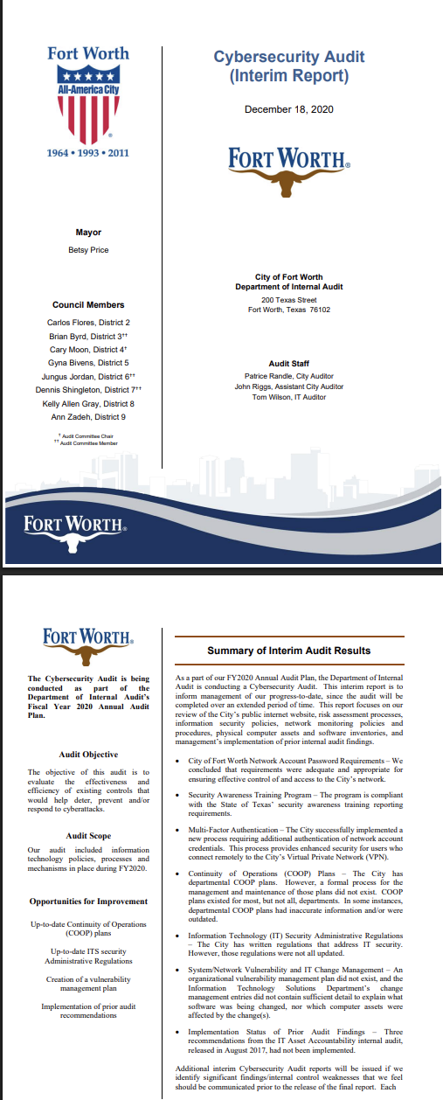
This is a sample of the security audit plan that I analyzed by the city of Fort Worth.

Chapter 11: Case Study

Assignment:
Juan Garcia is the network administrator for a small company that also maintains its own web server. He has taken the following precautions:
All computers are patched, have antivirus software, and have unneeded services shut down.
The network has a firewall with proxy server and IDS.
The organization has a policy requiring passwords of 10 characters in length, and they must be changed every 90 days.
Consider the following questions:
Has Juan done enough to secure the network?
What other actions would you recommend he take?

Assignment response:
Question 1 Response:
Juan has not done enough to secure the network. There are always more actions to take when securing a network.

Questions 2 Response:
As stated, Juan could always do more in order to better secure the company’s network. For example, Juan could establish more physical security, such as keeping the web servers in a locked cooling room. This room could only be accessed by authorized key cards, limiting untrained or unauthorized personnel to gain access to the room.
Juan could also establish a DMZ (Demilitarized Zone) for the network in order to limit direct access to the company’s network. As we discussed in class, Juan could upgrade the IDS to a more secure and trustworthy IPS system. Not only would this alert Garcia of any attacker, but it would also attempt to limit the attack itself. In my report about the audit plan for Fort Worth, the IT team decided to establish MFA (Multi-Factor Authentication), which could be implemented for Juan’s company.
If Garcia were able to monitor all of these systems, he could consider a SIEM (Security Information and Event Management) so all of the loggings could be in one place. Along with all of these additions, Juan should conduct regular security audits to review not only the security systems in place, but also to review policies the security team or company created or adopted. Enacting a Principle of Least Privilege could also be of benefit to the security of the company, limiting access for employees who do not need to access the networking system. This would also include limiting access for employees that need the system, specifically in certain areas that are outside of their work requirement.
Another field that Garcia could benefit from is the creation of security agreements or small courses for the employees. These would be mandatory to ensure that all employees know the importance of the security for the web server.
Overall, Juan could always implement more security measures for the company. This would ensure the safety of not only the assets and reputation of the company, but also the security of sensitive employee data.

References

- https://www.fortworthtexas.gov/files/assets/public/v/3/internal-audit/documents/fy2021/2020-12-18-cybersecurity-interim-audit.pdf
- https://au.instructure.com/courses/44142/files/5413237?module_item_id=2666205
- https://www.sans.org/information-security-policy
- https://nsacyber.github.io/publications.html
- https://www.dataguard.com/blog/best-cybersecurity-measures/

